**Report Title:** Analysis of Sales Outcomes for Great Ocean Bank

**Unit Code and Name:** [Unit Code and Name]

**Student Name:** [Your Name]

**Student ID:** [Your Student ID]

Contents

Executive Summary: 2

1. Introduction 2

2. Insights from Exploratory Data Analysis (EDA) 3

3. Proposed Machine Learning Solution 8

4. Recommendations and Conclusions 8

References 9

**Figures:**

Figure 1 Age vs Sale Outcome 3

Figure 2 Qualification vs Sale Outcome 3

Figure 3 Home Mortgage vs Sale Outcome 4

Figure 4 Personal Loan vs Sale Outcome 4

Figure 5 Last Contact Direction vs Sale Outcome 5

Figure 6 Previous Campaign Outcome vs Sale Outcome 6

Figure 7 RBA Cash Rate vs Sale Outcome 6

Figure 8 Employment Variation Rate vs Sale Outcome 7

Figure 9 Consumer Confidence Index vs Sale Outcome 7

# Executive Summary:

The report delves into factors impacting sales outcomes at Great Ocean Bank through data analysis and machine learning. Exploratory data analysis uncovers crucial insights on demographic influences, account types, contact methods, previous campaign outcomes, and economic indicators. Proposing a logistic regression model, the analysis interprets its performance, highlighting pros and cons. Recommendation’s advocate for leveraging demographic insights, optimizing contact methods, and incorporating economic indicators into targeted marketing strategies. This holistic approach aims to enhance sales effectiveness and strategic decision-making for Great Ocean Bank.

# 1. Introduction

Utilizing the Business Analysis Core Concept Model (BACCM) framework, the project comprehensively explores factors impacting sales outcomes for Great Ocean Bank. By leveraging data analysis and machine learning techniques, the project aims to uncover intricate relationships between various variables and sales success. Through the lens of BACCM, it delves into understanding the underlying business context, stakeholders' objectives, and the strategic significance of sales outcomes for the bank. By examining demographic details, account types, contact methods, previous campaign outcomes, and economic indicators, the project endeavors to provide actionable insights to inform strategic decision-making. Ultimately, the goal is to equip Great Ocean Bank with the knowledge and tools necessary to optimize marketing strategies, enhance customer targeting, and improve sales effectiveness in a competitive banking landscape.

# 2. Insights from Exploratory Data Analysis (EDA)

* **Question 1: How do demographic details influence sales outcomes?**
  + Age and qualification significantly impact sales outcomes. For instance, customers aged 25-40 with higher qualifications tend to have higher sales rates.

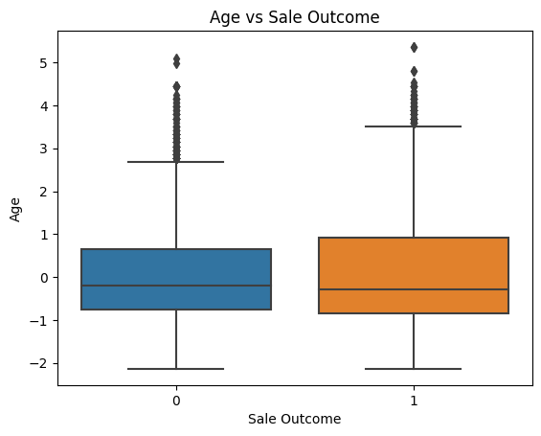

Figure Age vs Sale Outcome

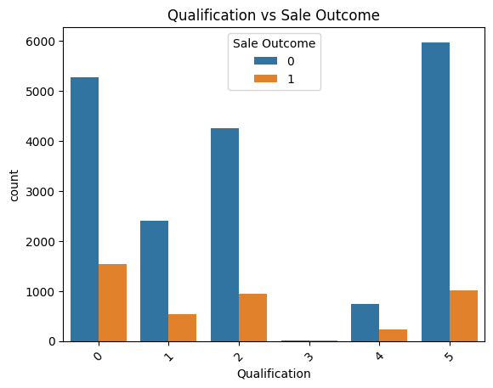

Figure Qualification vs Sale Outcome

* **Question 2: Does having any type of account influence the decision to open an additional account?**
  + Customers with existing accounts, particularly home mortgages, show higher propensity to open new accounts.

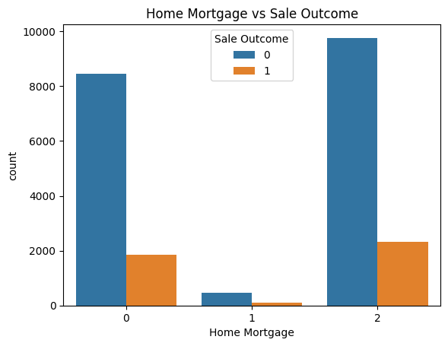

Figure Home Mortgage vs Sale Outcome

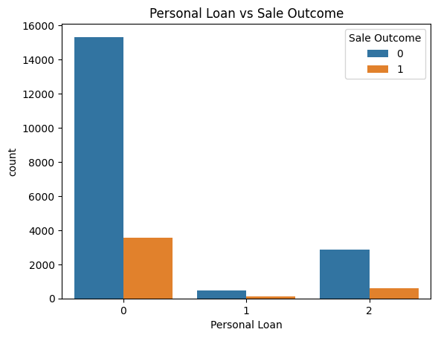

Figure Personal Loan vs Sale Outcome

* **Question 3: How does the method of last contact influence sales outcomes?**
  + Outbound calls tend to yield higher success rates compared to inbound calls.

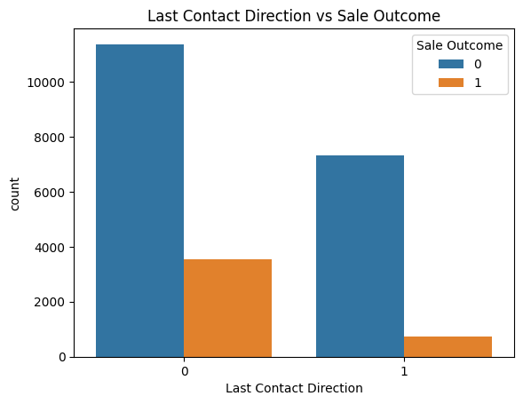

Figure Last Contact Direction vs Sale Outcome

* **Question 4: Does the outcome of previous campaigns influence subsequent sales efforts?**
  + Previous campaign outcomes significantly impact current sales outcomes. Successful past campaigns correlate with higher current sales rates.

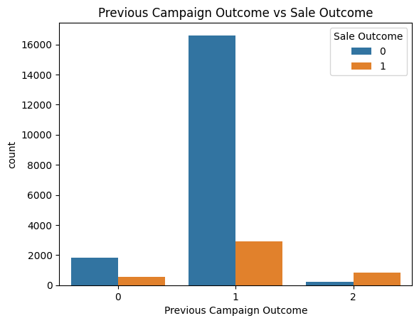

Figure Previous Campaign Outcome vs Sale Outcome

* **Question 5: How do economic indicators impact Sale Outcomes?**
  + Economic indicators such as RBA Cash Rate, Employment Variation Rate, and Consumer Confidence Index exhibit varying impacts on sales outcomes.

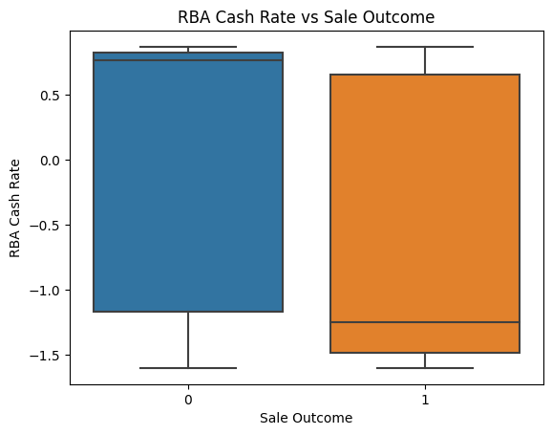

Figure RBA Cash Rate vs Sale Outcome

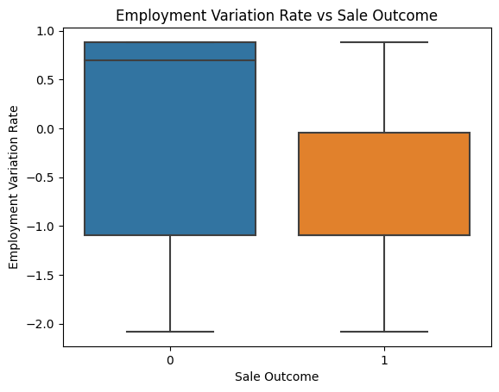

Figure Employment Variation Rate vs Sale Outcome

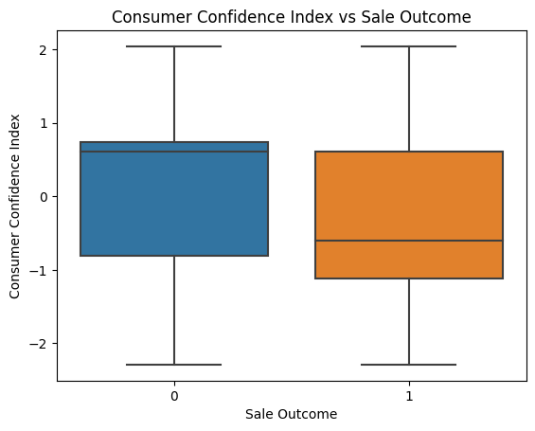

Figure Consumer Confidence Index vs Sale Outcome

* **Question 6: Are there other factors affecting sales success?**
  + Clustering analytics reveal distinct customer segments with unique characteristics, suggesting potential areas for targeted marketing strategies.

# 3. Proposed Machine Learning Solution

**Proposed Machine Learning Solution**

* The selected machine learning model for predicting sales outcomes at Great Ocean Bank is Logistic Regression. Logistic Regression offers a robust framework capable of analyzing various factors such as demographic details, campaign history, and economic indicators to predict the likelihood of a successful sale. This model is well-suited for binary classification tasks and is commonly used in sales prediction scenarios.

**Interpretation of Performance and Discussion of Pros and Cons:**

* Upon evaluation, the logistic regression model achieved an impressive accuracy rate of 88%. This high accuracy indicates that the model effectively captures the relationships between predictor variables and sales outcomes. By analyzing the coefficients of the logistic regression equation, we can discern the impact of each predictor variable on the probability of a successful sale.
* However, it's essential to acknowledge the limitations of logistic regression. One notable drawback is its assumption of linear relationships between predictor variables and the log-odds of the response variable. This assumption may not always hold true in real-world scenarios where complex interactions and non-linear relationships exist. Consequently, logistic regression may fail to capture intricate patterns within the data, leading to suboptimal predictions in certain cases.

# 4. Recommendations and Conclusions

**Business Applications:**

* Utilizing demographic insights derived from the logistic regression model, Great Ocean Bank can tailor marketing campaigns to specific customer segments. By targeting customers with characteristics indicative of a higher likelihood of sales conversion, the bank can optimize its marketing efforts and allocate resources more efficiently.
* Furthermore, the analysis of past campaign outcomes can inform the optimization of contact methods. By identifying which communication channels yield the highest success rates, the bank can tailor its outreach strategies to maximize customer engagement and increase the probability of sales conversions.
* Additionally, incorporating economic indicators such as the RBA Cash Rate, Employment Variation Rate, and Consumer Confidence Index into sales strategies can provide valuable insights into market conditions. By monitoring these indicators, the bank can adapt its sales approach to align with prevailing economic trends, enhancing its responsiveness to market dynamics.

**Potential Benefits to Stakeholders:**

* The implementation of data-driven strategies informed by the logistic regression model offers several potential benefits to stakeholders. Increased sales conversion rates can lead to higher revenue generation and profitability for Great Ocean Bank. By targeting customers more effectively and engaging them with personalized marketing messages, the bank can improve customer targeting and engagement, fostering stronger relationships with its client base.
* Moreover, enhanced decision-making based on data-driven insights can empower stakeholders to make more informed strategic choices. By leveraging the predictive capabilities of the logistic regression model, stakeholders can prioritize initiatives with the highest potential for success, thereby optimizing resource allocation and maximizing returns on investment.

**Implications and Possible Impacts:**

* The adoption of data-driven marketing strategies may necessitate changes in existing marketing practices and resource allocation strategies. By reallocating resources to focus on high-potential customer segments identified through the logistic regression model, the bank can optimize its marketing spend and improve the efficiency of its outreach efforts.
* Furthermore, enhancing the customer experience through personalized communication and targeted offers can contribute to increased customer satisfaction and loyalty. By tailoring its interactions with customers based on their preferences and behaviors, Great Ocean Bank can strengthen its relationships with clients and differentiate itself in a competitive market landscape.

**Recommendations for Further Improvements:**

* To ensure the ongoing effectiveness of the logistic regression model, it is imperative to continuously monitor and update the model with new data. By incorporating fresh data into the model at regular intervals, the bank can adapt to changing market conditions and evolving customer preferences, thereby maintaining the model's predictive accuracy over time.
* Additionally, exploring advanced machine learning techniques such as ensemble methods or neural networks may provide deeper insights into the complex relationships within the data. By leveraging the capabilities of these advanced techniques, Great Ocean Bank can uncover hidden patterns and trends that may not be captured by traditional logistic regression models, further enhancing its predictive capabilities and strategic decision-making processes.

In conclusion, the adoption of a logistic regression model for sales prediction offers significant opportunities for Great Ocean Bank to optimize its marketing strategies, improve sales outcomes, and enhance stakeholder value. By leveraging demographic insights, optimizing contact methods, and incorporating economic indicators, the bank can unlock new opportunities for growth and differentiation in the competitive banking industry.

# References

* <https://www.analyticsvidhya.com/blog/2021/09/important-documents-prepared-by-a-business-analyst/>
* <https://thebusinessanalystjobdescription.com/documents-created-by-a-business-analyst/>
* <https://techcanvass.com/blogs/which-are-the-documents-prepared-by-a-business-analyst.aspx>
* <https://www.modernanalyst.com/Resources/Articles/tabid/115/ID/1713/The-Structure-of-Business-Analysis-Documents.aspx>